GEN_AI LAB 12
Building a Simple LLM Agent Using the Phi Data Framework
Name: Shiva Dhanush S
USN: 1RVU23CSE428
Date: 08-04-2026
Introduction
This lab was implemented using Agno, which is the current successor to the Phi Data framework. The agent was executed locally with Ollama and the free `qwen2.5:3b` model, so the report is based on real runtime outputs rather than a manual-only description.
Objective
- To build a simple role-based LLM agent using the modern Agno framework.
- To configure a local model backend through Ollama.
- To observe how the same agent responds consistently across multiple prompts.
- To document the execution evidence with notebook-style output captures.
Tools and Platforms Used
Tool / Platform | Purpose in the Experiment
Agno | Used as the agent framework; documented as the current successor to Phi Data.
Ollama | Used to run the local open-source model backend.
qwen2.5:3b | Free local model used by the agent.
Jupyter Notebook | Used to store the experiment workflow and outputs.

Methodology / Procedure
- Install Agno and confirm local Ollama access.
- Define a study-assistant agent with role, instructions, and concise-response behavior.
- Run three prompts covering concept explanation, applications, and viva preparation.
- Save the notebook and capture the resulting outputs as evidence images.
Implementation / Workflow Summary
The notebook initializes an Agno agent called Campus Study Assistant and attaches the `qwen2.5:3b` model through the Ollama provider. The instructions guide the agent to answer in a practical, student-friendly style suitable for a Gen AI lab record or viva preparation.
The executed notebook file is stored at: C:\Users\licha\OneDrive\Desktop\Gen-AI\output\jupyter-notebook\lab_12_agno_agent_428.ipynb
Observed Agent Prompts
- Explain what an LLM agent is in simple terms for a lab record.
- Give three practical uses of AI agents in education.
- Provide a four-step plan to prepare for a Gen AI viva tomorrow.
Screenshot Evidence
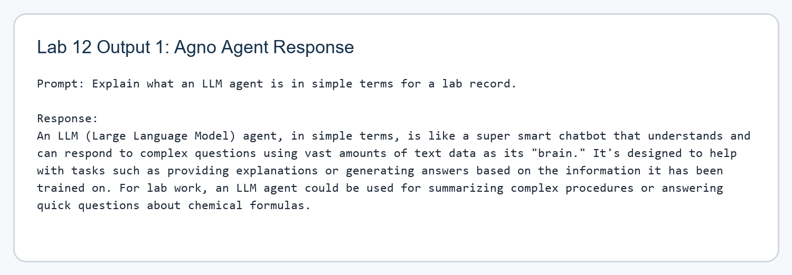
Figure 1. Local Agno agent response captured from the Lab 12 execution workflow.
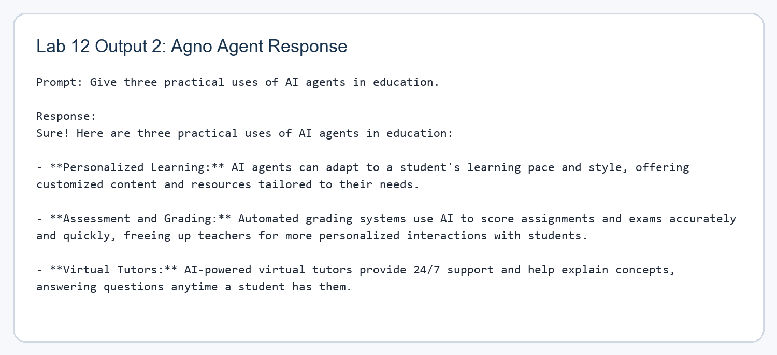
Figure 2. Local Agno agent response captured from the Lab 12 execution workflow.
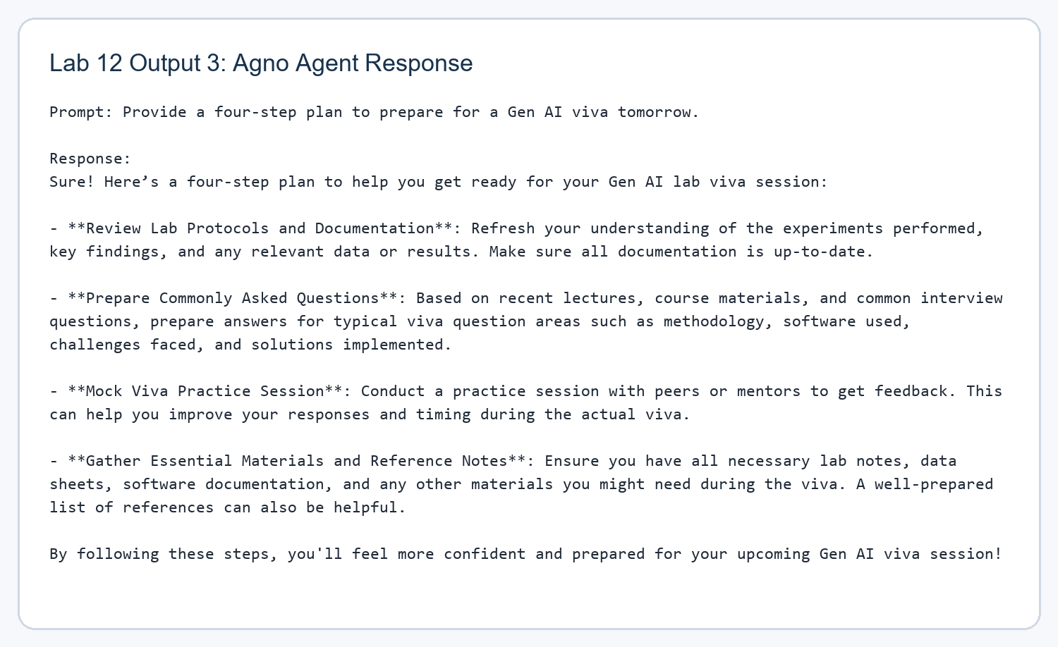
Figure 3. Local Agno agent response captured from the Lab 12 execution workflow.
Observations
The agent responded coherently across all three prompts and preserved the intended helpful study-assistant tone. This shows that the agent abstraction is working as more than a one-off prompt; the role and instructions remain active across repeated interactions.
The local Ollama setup also makes the experiment reproducible without paid APIs, which is useful for future lab revisions or viva demonstrations.
Result / Conclusion
The lab was successfully completed using a free local stack based on Agno and Ollama. The notebook and screenshots confirm that a simple LLM agent was created, configured, and tested successfully.

